TALIBON POLYTECHNIC COLLEGE
BA Capstone Project: Final Capstone Report
Checkpoint 4 — Capstone Analytics Project & Final Defense
Retail & Sales Analytics: Customer Segmentation & Purchase Behavior Analysis
Course Code / Title | BED 106 — Business Analytics
Document | Integrated Capstone Report (Checkpoints 1–4)
Group Name / Number | ________________________
Submission Date | ________________________
Academic Year | 2026–2027, 1st Semester
Instructor | Jessie A. Melendres

Team Members & Roles
Member | Role
Jeziel Lea Mitch Credo | Project Lead / Analyst & BI Developer / Visualizer
Nicka Hinlayagan | Data Engineer
Jennilyn Manatad | Statistician / Modeler

Contents
1 Title Page
2 Executive Summary
3 Business Problem & Data Source
4 Database Design & SQL Analysis
5 Statistical Analysis
6 BI Dashboard Summary
7 Predictive Analytics
8 Ethics & Governance
9 Conclusions & Recommendations
10 References
11 Appendix

2 Executive Summary
This page is a one-page synopsis of the business problem, the methods used and the key findings. Write it in your own words, using the facts below.
GROUP TO WRITE — facts to build the summary from
Problem: the retailer treats every customer the same way, so marketing is untargeted, high-value customers are not specifically retained, and returned/cancelled products go unflagged.
Data: UK online gift retailer transactions (UCI/Kaggle “Online Retail”), 1–3 Dec 2010 sample: 300 invoices (271 completed, 29 cancelled), 207 customers, £106,185.83 completed revenue.
Methods: MySQL database + 8 SQL queries (CP1); Excel descriptive stats, correlation, simple regression (CP2); Power BI 3-page dashboard + K-Means segmentation, k = 3 (CP3); multiple regression (CP4).
Key results: 4 High-Value customers (2.1%) = 27.2% of revenue; Mid-Value (56.1% of customers) = 59.4% of revenue; the multiple regression explains 80.2% of invoice-value variation (adj. R² 0.800) vs 47.8% for the simple model.
Main caution: only ~3 days of data, so frequency-based findings and the model should not be generalised beyond this sample.

3 Business Problem & Data Source

3.1 Business Domain & Problem
Retail & Sales Analytics: this project analyzes transaction-level sales data from a UK-based online gift retailer to understand who the company’s customers are and how they buy. The core problem is that the business currently treats all customers the same way in its marketing and inventory decisions, even though purchase value, frequency, and product preference vary widely across its customer base.

3.2 Business Impact & Significance
Without customer segmentation, marketing spend is not targeted, high-value customers are not specifically retained, and slow-moving or frequently-returned products keep tying up inventory. Segmenting customers by purchase behavior lets the business focus retention campaigns on high-value buyers, tailor promotions to one-time or low-value customers to increase repeat purchase rate, and flag products with unusually high return rates before they erode margin.

3.3 Key Business Questions
- Which customers are the most valuable, and how can they be segmented by total spend and order frequency to support targeted marketing?
- Which products and which countries generate the most revenue, and where should inventory and marketing investment be focused?
- What patterns exist in order cancellations/returns, and which products are most frequently returned?

3.4 Data Source Report
Attribute | Details
Dataset name | Online Retail Data Set (UCI Machine Learning Repository; mirrored on Kaggle as “online-retail-data-set-from-uci-ml-repo”)
Source URL / file | https://www.kaggle.com/datasets/jihyeseo/online-retail-data-set-from-uci-ml-repo
Date accessed | 2026-08-21
License | CC BY 4.0 (Creative Commons Attribution 4.0 International)
Sample analysed | 300 invoices / 5,129 lines, 2010-12-01 to 2010-12-03; 207 customers; 1,597 products
Table 3.1. Data source report

3.5 Data Dictionary
Column | Data type | Description
InvoiceNo | VARCHAR(10) | 6-digit transaction number; a leading “C” marks an order cancellation.
StockCode | VARCHAR(20) | Product code, usually 5 digits optionally followed by a letter.
Description | VARCHAR(150) | Product name.
Quantity | INTEGER | Units purchased on that line; negative values are returns/cancellations.
InvoiceDate | DATETIME | Date and time the transaction was generated.
UnitPrice | DECIMAL(10,2) | Unit price in GBP (£).
CustomerID | INTEGER (nullable) | 5-digit customer identifier; blank when the order was a guest checkout.
Country | VARCHAR(50) | Customer’s country of residence.
Table 3.2. Data dictionary

3.6 Data Quality Assessment & Cleaning
- Missing values: CustomerID is blank on 135,080 of 541,909 raw rows (24.9%) — guest checkouts. Description is blank on 1,454 rows.
- Duplicates: 5,268 exact duplicate transaction-line rows in the raw file.
- Inconsistencies: 3,036 rows with inconsistent Description casing; 2,910 rows with non-merchandise StockCodes (POST, DOT, M, C2, D, S, BANK CHARGES, PADS, CRUK, B); 2,517 rows with zero/negative UnitPrice on a non-cancelled line.
- Cleaning applied: standardized text; removed the 5,268 duplicates, the 2,910 adjustment codes, 1,448 rows with missing description and 1,047 rows with invalid price; kept legitimate cancellations (InvoiceNo starting with “C”); split the cleaned file into four normalized tables.

4 Database Design & SQL Analysis

4.1 Final Entity-Relationship Diagram
The cleaned data was normalized into four related tables in MySQL (phpMyAdmin): customers, invoices, invoice_items and products.
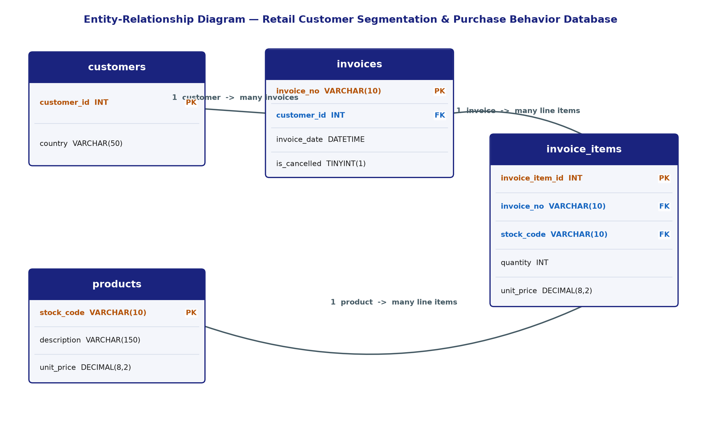
Figure 4.1. Entity-Relationship Diagram — retail_customer_analytics database
Table | Rows | Keys & purpose
customers | 207 | PK customer_id; country of each registered customer
invoices | 300 | PK invoice_no; FK customer_id; invoice_date; is_cancelled flag
invoice_items | 5,129 | PK invoice_item_id; FK invoice_no, stock_code; quantity, unit_price
products | 1,597 | PK stock_code; description; list unit_price
Table 4.1. Cleaned tables and keys

4.2 SQL Query Summary
# | Type | Business purpose
1 | SELECT + WHERE + ORDER BY | High-value order lines (line total ≥ £15), most expensive first
2 | SELECT + WHERE | Customers based in Germany or France
3 | GROUP BY + aggregates | Revenue and completed-order count per country
4 | GROUP BY + aggregates | Top-selling products by quantity, average price and revenue
5 | JOIN | Top 10 completed invoices by total value
6 | 3-table JOIN | Full order detail for one invoice
7 | Business insight | Customer segmentation by spend and order frequency
8 | Business insight | Products most frequently cancelled / returned
Table 4.2. The eight SQL queries (full code in checkpoint1_setup.sql)

4.3 Key SQL Results
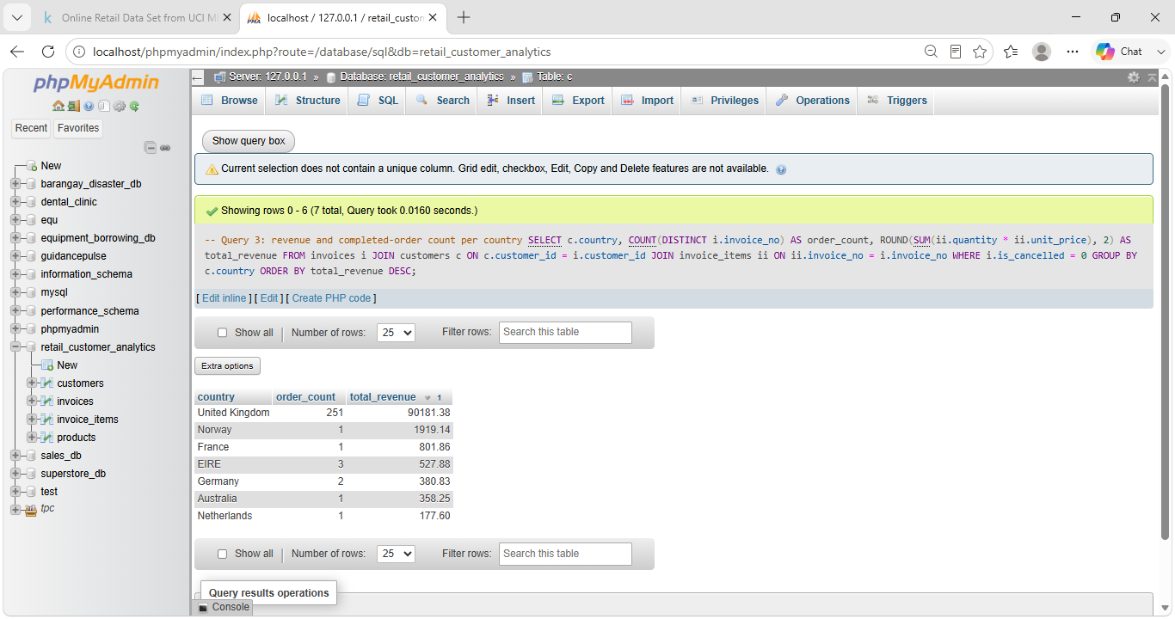
Figure 4.2. Query 3 result — revenue and completed orders by country
The country breakdown confirms the business is overwhelmingly UK-driven in this sample, with international orders still a small but present fraction of revenue — useful for deciding where to prioritize localized marketing.
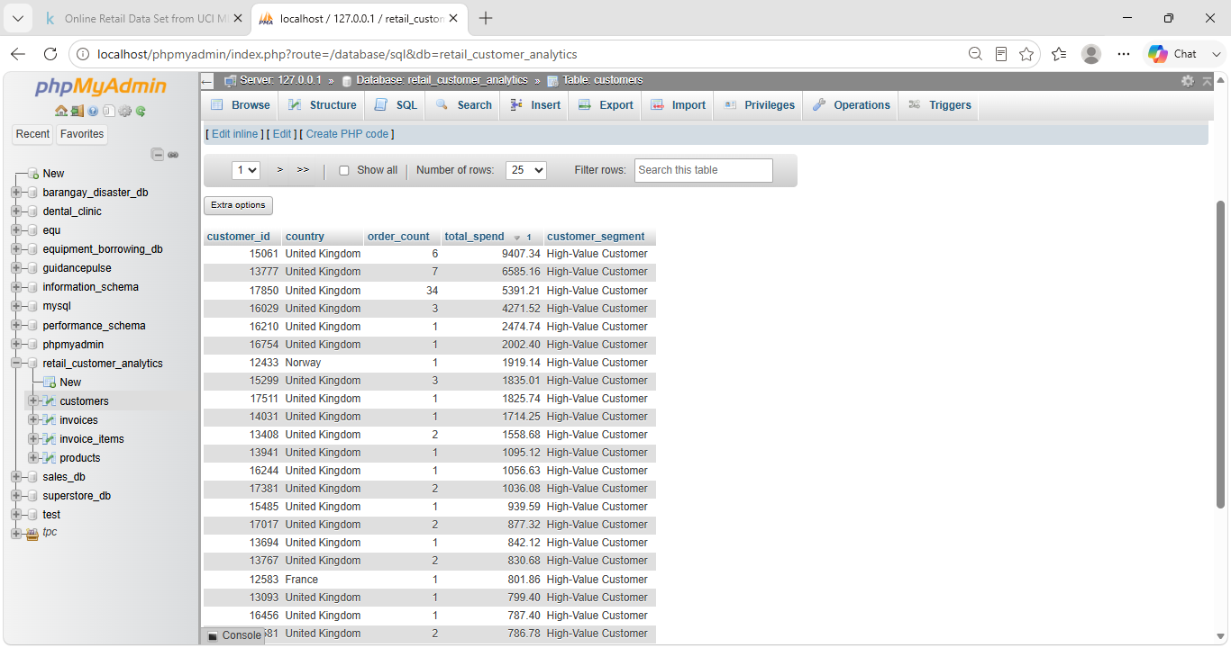
Figure 4.3. Query 7 result — customer segmentation by spend and frequency
Query 7 directly answers the project’s central question: it splits the customer base into High-Value, Repeat, and One-Time/Low-Value segments using spend and order count, giving marketing a concrete target list for retention offers versus reactivation campaigns.
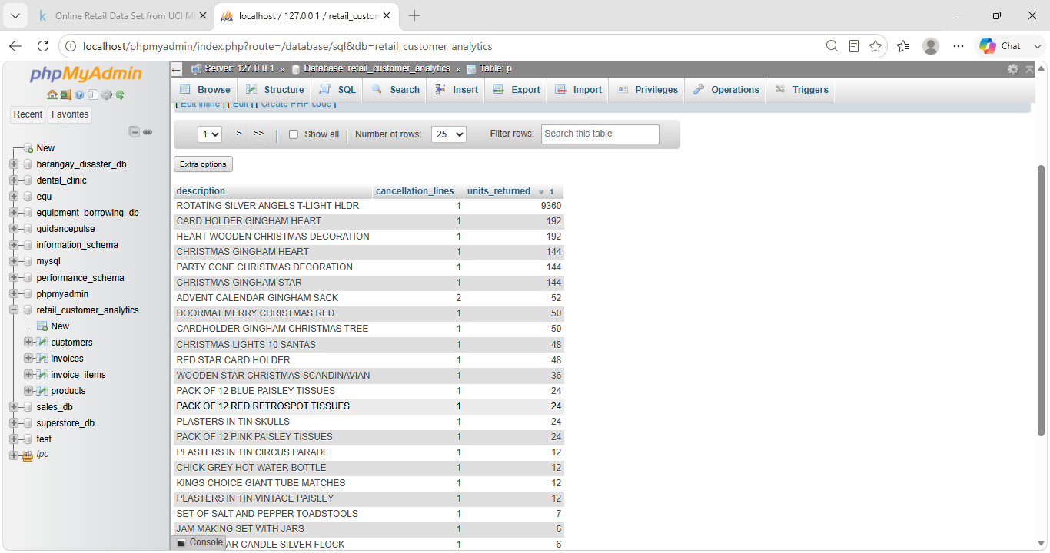
Figure 4.4. Query 8 result — most frequently cancelled / returned products
Query 8 flags which specific products carry the highest cancellation/return volume; a single large cancelled order can distort this figure (as with the top row here), so this list should be reviewed alongside order size before concluding a product genuinely has a quality problem.

5 Statistical Analysis
Computed in Excel on the 5,055 completed order lines (workbook: Checkpoint 2 - Spreadsheet & Statistical Analysis.xlsx).

5.1 Descriptive Statistics
Statistic | Quantity | Unit Price (£) | Line Total (£)
Mean | 11.61 | 3.54 | 21.01
Median | 3.00 | 2.51 | 10.20
Mode | 1.00 | 1.25 | 15.00
Std. deviation | 58.30 | 6.04 | 60.80
Variance | 3,399.44 | 36.49 | 3,696.18
Range | 2,879.00 | 294.90 | 1,626.91
Min | 1.00 | 0.10 | 0.29
Max | 2,880.00 | 295.00 | 1,627.20
Table 5.1. Descriptive statistics, completed order lines (n = 5,055)
All three variables are strongly right-skewed: means sit well above medians, and a handful of bulk lines (up to 2,880 units, £1,627.20) pull averages up. Typical basket size should therefore be planned from the median, with bulk orders handled as a separate category.
1 | 2 | 3–5 | 6–10 | 11–25 | 26–50 | 51–100 | 100+
1,509 | 700 | 730 | 814 | 981 | 175 | 81 | 65
Table 5.2. Frequency distribution — quantity per order line (number of lines per bucket)

5.2 Correlation Analysis
Pair | Pearson r | Reading
Quantity vs Unit Price (line level) | −0.057 | Very weak / no linear relationship
Items per Invoice vs Invoice Value (n = 271) | 0.691 | Moderately strong positive
Table 5.3. Correlation results
Price alone is a poor predictor of order size, while the number of distinct items on an invoice moves strongly with invoice value — so basket size, not price, is the more reliable revenue lever.

5.3 Simple Linear Regression (Checkpoint 2)
Y = Invoice Value (£); X = Items per Invoice (lines). Equation: Invoice Value = 217.49 + 9.35 × Items per Invoice.
Metric | Value
Slope (b) | 9.346
Intercept (a) | 217.492
R-squared | 0.4777
Correlation (R) | 0.6912
p-value (slope) | < 0.0001
n (invoices) | 271
Predicted value, X = 10 items | £310.95
Table 5.4. Simple regression summary
About 47.8% of the variation in invoice value is explained by the number of items; each extra line is associated with about £9.35 more in invoice value. The intercept is inflated by a few very large bulk orders, and the model ignores product mix, country and time of purchase.

5.4 Trend Analysis
The hourly revenue trend (24 buckets, 1–3 Dec 2010) was Revenue = 5,500.50 − 93.57 × t, R² = 0.047, p = 0.31 — not statistically significant. The forecast is illustrative only; a real trend or seasonal forecast needs a longer window of the source dataset (which runs to 2011-12-09).

6 BI Dashboard Summary
The Power BI dashboard (“Customer Segmentation Dashboard.pbix”) has three pages built from five CSV tables with the same relationships as the Checkpoint 1 ERD, plus a segment table linked on customer_id.

6.1 Page 1 — Executive Summary
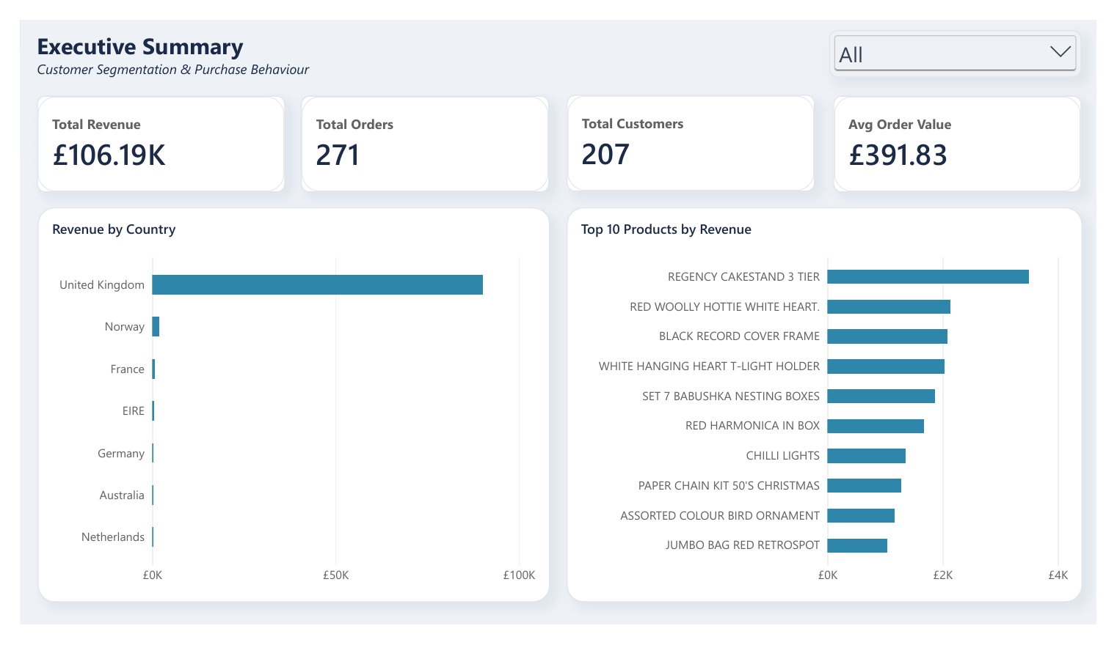
Figure 6.1. Executive Summary page: 4 KPI cards, revenue by country, top-10 products, country slicer
KPIs: Total Revenue £106.19K, Total Orders 271, Total Customers 207, Average Order Value £391.83.

6.2 Page 2 — Trend & Comparison Analysis
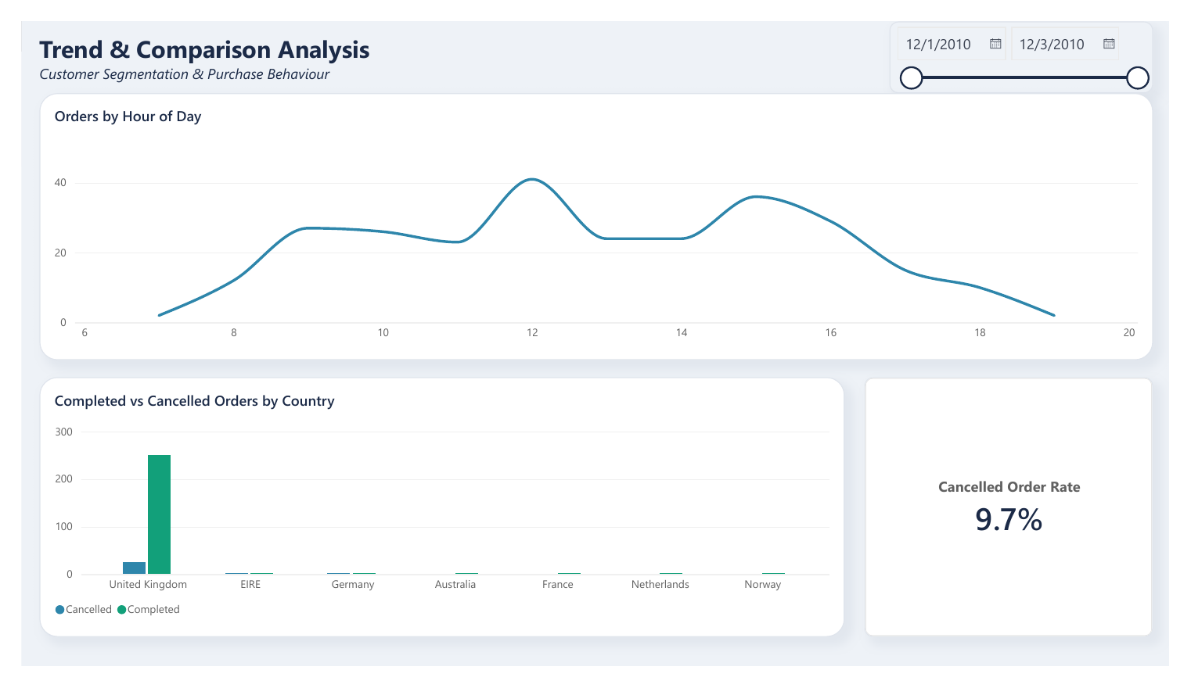
Figure 6.2. Trend & Comparison page: orders by hour, completed vs cancelled orders by country, date-range slicer
Cancelled-order rate: 9.7% (29 of 300 invoices).

6.3 Page 3 — Customer Segmentation Deep Dive
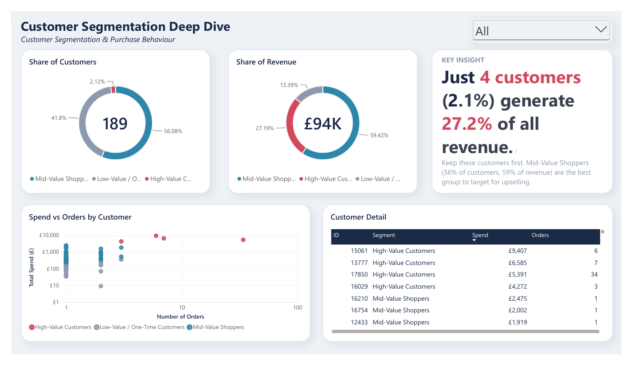
Figure 6.3. Segmentation page: customer and revenue share donuts, spend-vs-orders scatter, customer detail table, segment slicer

6.4 Segmentation Method & Results
K-Means clustering was run on 189 customers with at least one completed non-guest order, using log-transformed and standardized total spend, order count and average order value. Silhouette scores: k = 2: 0.553; k = 3: 0.437; k = 4: 0.487; k = 5: 0.463. k = 3 was chosen as the smallest number giving distinct, actionable groups.
Segment | Cust. | % cust. | Avg spend | Avg orders | Avg order value | Revenue share
High-Value Customers | 4 | 2.1% | £6,413.81 | 12.5 | £1,022.76 | 27.2%
Mid-Value Shoppers | 106 | 56.1% | £528.88 | 1.1 | £477.57 | 59.4%
Low-Value / One-Time | 79 | 41.8% | £159.88 | 1.1 | £147.54 | 13.4%
Table 6.1. Customer segments (source: segment_summary.csv)
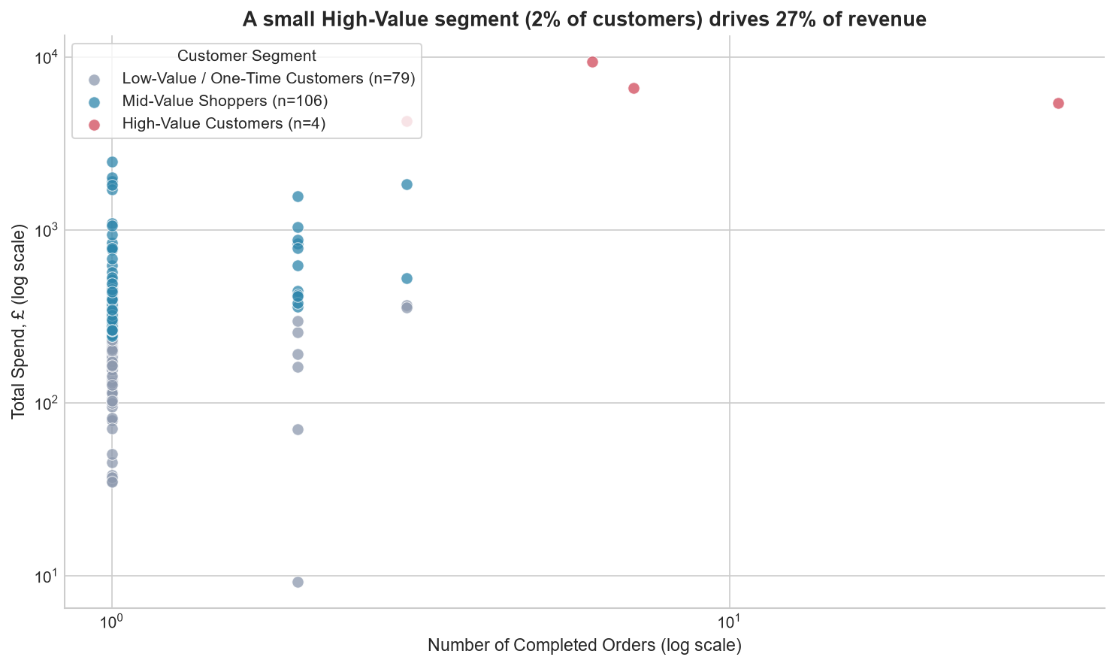
Figure 6.4. K-Means customer segments (log scale)
Limitation: the sample spans only 3 days, so order count is compressed — the High-Value segment is a reliable signal, but the Mid vs Low split reflects spend per order, not true loyalty.
GROUP TO WRITE — discussion of the dashboard story
Write 1 short paragraph per dashboard page: what the page shows and the business insight you would tell the class. Link each page back to key business questions 1–3.

7 Predictive Analytics

7.1 Model Description
Technique: multiple linear regression, extending the Checkpoint 2 simple regression. The model predicts the value of a completed invoice from its basket composition. It was computed in Excel with LINEST (same output as the Data Analysis ToolPak) — see “Checkpoint 4 - Predictive Model.xlsx”.
Role | Variable | Definition
Output (Y) | Invoice Value (£) | Sum of quantity × unit price over all lines of a completed invoice
Predictor X1 | Lines per invoice | Number of distinct product lines on the invoice
Predictor X2 | Total quantity | Total units on the invoice
Table 7.1. Model variables (n = 271 completed invoices)
Fitted equation: Invoice Value = 52.65 + 7.20 × Lines + 0.946 × Quantity
Coefficient | Estimate | Std. error | t Stat | P-value
Intercept | 52.652 | 20.952 | 2.513 | 0.0126
X1: Lines per invoice | 7.202 | 0.382 | 18.867 | < 0.0001
X2: Total quantity | 0.946 | 0.045 | 20.937 | < 0.0001
Table 7.2. Regression coefficients (95% CI: lines 6.45–7.95; quantity 0.857–1.035)

7.2 Model Performance
Metric | Value
R-squared | 0.8018
Adjusted R-squared | 0.8004
Multiple R | 0.8955
Standard error of Y | £299.03
F-statistic (df 2, 268) | 542.24 (Significance F < 0.0001)
Mean absolute error | £151.85 (38.8% of mean invoice value)
Observations | 271
Table 7.3. Model fit statistics
Model | R² | Adj. R² | Gain in R²
M1 (Checkpoint 2): Lines only | 0.4777 | 0.4760 | baseline
M2 (final): Lines + Quantity | 0.8018 | 0.8004 | +0.3241
M3: M2 + Avg unit price | 0.8028 | 0.8008 | +0.0009
Table 7.4. Model comparison — adding average price improves R² by under 0.001
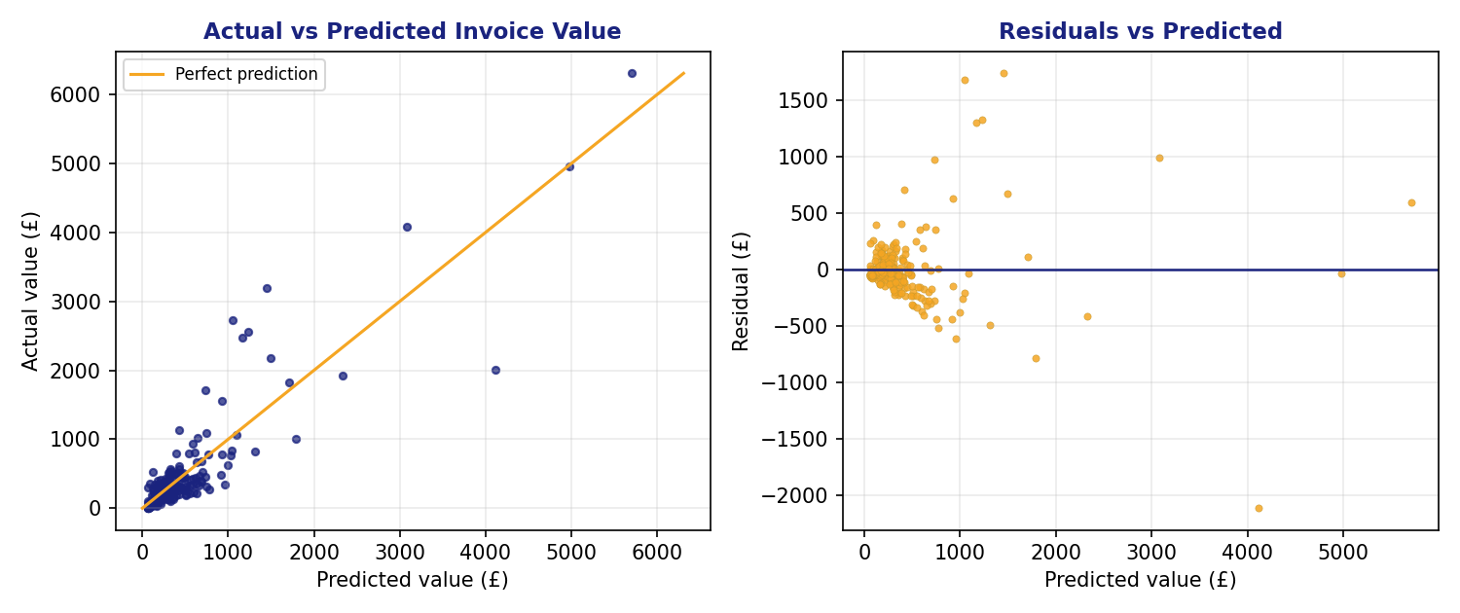
Figure 7.1. Actual vs predicted invoice value (left) and residuals vs predicted (right)

7.3 Predictions
Scenario | Lines | Units | Predicted | Approx. range
Small basket | 3 | 30 | £102.64 | £0 – £689
Typical basket (median invoice) | 11 | 106 | £232.15 | £0 – £818
Average basket | 19 | 217 | £394.78 | £0 – £981
Large basket | 30 | 400 | £647.13 | £61 – £1,233
Typical basket + 5 extra lines | 16 | 106 | £268.16 | £0 – £854
Typical lines + 100 extra units | 11 | 206 | £326.76 | £0 – £913
Table 7.5. Predicted invoice values (range = prediction ± 1.96 × £299.03, approximate; live calculator in the workbook)

7.4 Recommendations
GROUP TO WRITE — at least 3 actionable recommendations
Each recommendation must follow from the model output (coefficients, predictions) — state the action, the evidence, and the expected effect.
Evidence to use: one extra product line adds about £7.20 holding quantity constant; one extra unit adds about £0.95 holding lines constant; average unit price added almost nothing (ΔR² = 0.0009; p = 0.26 in M3); segments from Section 6 show where basket-building matters most.

7.5 Assumptions, Limitations & Conditions
GROUP TO WRITE — assumptions and limitations of the model
Facts from the Diagnostics sheet to discuss: 13 of 271 invoices (4.8%) have residuals larger than 2 × the standard error; largest misses are +£1,743 and −£2,114; max invoice £6,308 vs median £248 (heavy skew); the residual plot suggests unequal spread at higher values.
Predictors are not collinear (r = 0.27, VIF ≈ 1.08). The prediction band is wide (±£586), so the model is better for comparing scenarios than for exact invoice forecasts.
Invoice value is quantity × price, so quantity is partly built into the output; sample is only 3 days (1–3 Dec 2010) and 271 invoices from one retailer — re-fit before using on another period.
Discuss: why a trend-based forecast was NOT used (Checkpoint 2 trend R² = 0.047, p = 0.31).

8 Ethics & Governance
Minimum 500 words, covering the four required areas below. Use your own words and your own judgment; the notes list facts from this project to help you think.

8.1 Privacy Considerations
GROUP TO WRITE — your reflection
Dataset has no names, emails or addresses — only a numeric CustomerID, country, and transaction details. CustomerID is blank on 24.9% of raw rows (guest checkouts).
Consider: is a numeric ID still “personal data” when combined with purchase history and timestamps? How was the data handled in this project (licence CC BY 4.0, public UCI/Kaggle source, no new data collected)?

8.2 Ethical Issues
GROUP TO WRITE — your reflection
The segmentation labels 4 customers “High-Value” — could treating segments differently (offers, service levels, prices) disadvantage the Low-Value / One-Time group?
Bias sources: only 3 days of data; UK-dominant sample; 29 cancelled invoices; guest customers excluded from segmentation (18 customers). Who is missing from the data?

8.3 Data Governance
GROUP TO WRITE — your reflection
Who owns the data (retailer / dataset donor / UCI repository)? What does CC BY 4.0 require of you?
What would a responsible framework look like here: access control, retention period, anonymization, documentation, review of model use?

8.4 Regulatory Awareness
GROUP TO WRITE — your reflection
Republic Act No. 10173 (Data Privacy Act of 2012) — Philippines; consider its principles (transparency, legitimate purpose, proportionality) and how they would apply if this analysis were run on a Philippine business’s customers.
GDPR concept (the retailer is UK-based): lawful basis, data minimisation, profiling and automated decision-making.

9 Conclusions & Recommendations
GROUP TO WRITE — synthesis and 3–5 actionable recommendations
Tie your conclusions back to the three business questions in Section 3.3: valuable customers (Sections 4, 6), revenue by product/country (Sections 4, 6), cancellations/returns (Sections 4, 6).
Pull together results from every checkpoint: SQL (CP1) → statistics (CP2) → dashboard & segments (CP3) → predictive model (CP4).
Each recommendation: action + supporting evidence + who should act. Include one sentence on what the group would do with a longer data window.

Recommendation 1: ________________________________________________
Recommendation 2: ________________________________________________
Recommendation 3: ________________________________________________
Recommendation 4: ________________________________________________
Recommendation 5: ________________________________________________

10 References
Format: APA 7th edition. Check each entry and its access date before submitting.
Chen, D. (2015). Online retail [Data set]. UCI Machine Learning Repository. https://archive.ics.uci.edu/
Chen, D. (n.d.). Online retail data set from UCI ML repo [Data set]. Kaggle. https://www.kaggle.com/datasets/jihyeseo/online-retail-data-set-from-uci-ml-repo (accessed August 21, 2026).
Melendres, J. A. (2026). BED 106 — Business Analytics: Mini business analytics capstone project [Course document]. Talibon Polytechnic College.
Microsoft Corporation. (2026). Microsoft Excel and Power BI Desktop [Computer software]. https://www.microsoft.com/
Pedregosa, F., Varoquaux, G., Gramfort, A., Michel, V., Thirion, B., Grisel, O., … Duchesnay, É. (2011). Scikit-learn: Machine learning in Python. Journal of Machine Learning Research, 12, 2825–2830.
Philippines. Republic Act No. 10173, Data Privacy Act of 2012. (2012). https://www.privacy.gov.ph/data-privacy-act/
Regulation (EU) 2016/679 of the European Parliament and of the Council of 27 April 2016 (General Data Protection Regulation). Official Journal of the European Union, L 119.

11 Appendix

Appendix A — Raw Data Sample
First 15 completed order lines from the cleaned dataset (invoice_items joined to products, invoices and customers).
InvoiceNo | Stock | Description | Qty | Date | Price | Cust. ID | Country
536365 | 85123A | WHITE HANGING HEART T-LIGHT HOLDER | 6 | 2010-12-01 08:26 | 2.55 | 17850 | United Kingdom
536365 | 71053 | WHITE METAL LANTERN | 6 | 2010-12-01 08:26 | 3.39 | 17850 | United Kingdom
536365 | 84406B | CREAM CUPID HEARTS COAT HANGER | 8 | 2010-12-01 08:26 | 2.75 | 17850 | United Kingdom
536365 | 84029G | KNITTED UNION FLAG HOT WATER BOTTLE | 6 | 2010-12-01 08:26 | 3.39 | 17850 | United Kingdom
536365 | 84029E | RED WOOLLY HOTTIE WHITE HEART. | 6 | 2010-12-01 08:26 | 3.39 | 17850 | United Kingdom
536365 | 22752 | SET 7 BABUSHKA NESTING BOXES | 2 | 2010-12-01 08:26 | 7.65 | 17850 | United Kingdom
536365 | 21730 | GLASS STAR FROSTED T-LIGHT HOLDER | 6 | 2010-12-01 08:26 | 4.25 | 17850 | United Kingdom
536366 | 22633 | HAND WARMER UNION JACK | 6 | 2010-12-01 08:28 | 1.85 | 17850 | United Kingdom
536366 | 22632 | HAND WARMER RED POLKA DOT | 6 | 2010-12-01 08:28 | 1.85 | 17850 | United Kingdom
536367 | 84879 | ASSORTED COLOUR BIRD ORNAMENT | 32 | 2010-12-01 08:34 | 1.69 | 13047 | United Kingdom
536367 | 22745 | POPPY'S PLAYHOUSE BEDROOM | 6 | 2010-12-01 08:34 | 2.10 | 13047 | United Kingdom
536367 | 22748 | POPPY'S PLAYHOUSE KITCHEN | 6 | 2010-12-01 08:34 | 2.10 | 13047 | United Kingdom
536367 | 22749 | FELTCRAFT PRINCESS CHARLOTTE DOLL | 8 | 2010-12-01 08:34 | 3.75 | 13047 | United Kingdom
536367 | 22310 | IVORY KNITTED MUG COSY | 6 | 2010-12-01 08:34 | 1.65 | 13047 | United Kingdom
536367 | 84969 | BOX OF 6 ASSORTED COLOUR TEASPOONS | 6 | 2010-12-01 08:34 | 4.25 | 13047 | United Kingdom
Table A.1. Raw data sample
Full data: Online Retail.xlsx (repository root); cleaned CSVs in Checkpoint 3/powerbi_data/.

Appendix B — Individual Contribution Forms
Signed forms for Checkpoints 1–3 are attached behind this page. Checkpoint 4 forms follow (one per member, to be completed and signed by each member).
Individual Contribution Form — BED 106 Capstone Project
Group Name / Number: ______________________________ Checkpoint No.: 4
Member Name: Jeziel Lea Mitch Credo Role: Project Lead / Analyst & BI Developer / Visualizer
Specific contributions this checkpoint:
1. ____________________________________________________________________
2. ____________________________________________________________________
3. ____________________________________________________________________
I certify that the contributions listed above are accurate and reflect my actual participation.
Signature: ________________________ Date: ________________
Individual Contribution Form — BED 106 Capstone Project
Group Name / Number: ______________________________ Checkpoint No.: 4
Member Name: Nicka Hinlayagan Role: Data Engineer
Specific contributions this checkpoint:
1. ____________________________________________________________________
2. ____________________________________________________________________
3. ____________________________________________________________________
I certify that the contributions listed above are accurate and reflect my actual participation.
Signature: ________________________ Date: ________________
Individual Contribution Form — BED 106 Capstone Project
Group Name / Number: ______________________________ Checkpoint No.: 4
Member Name: Jennilyn Manatad Role: Statistician / Modeler
Specific contributions this checkpoint:
1. ____________________________________________________________________
2. ____________________________________________________________________
3. ____________________________________________________________________
I certify that the contributions listed above are accurate and reflect my actual participation.
Signature: ________________________ Date: ________________

Appendix C — Peer Evaluation Forms
Each member rates all other members (1 = Poor, 5 = Excellent). Submit in a sealed envelope on defense day.
Peer Evaluation Form — Final Capstone Defense
Evaluator’s Name: Jeziel Lea Mitch Credo Group: ____________________
Member | Effort | Quality | Collab. | Commun. | Comments
Nicka Hinlayagan | /5 | /5 | /5 | /5
Jennilyn Manatad | /5 | /5 | /5 | /5

Evaluator’s Signature: ________________________ Date: ________________
Peer Evaluation Form — Final Capstone Defense
Evaluator’s Name: Nicka Hinlayagan Group: ____________________
Member | Effort | Quality | Collab. | Commun. | Comments
Jeziel Lea Mitch Credo | /5 | /5 | /5 | /5
Jennilyn Manatad | /5 | /5 | /5 | /5

Evaluator’s Signature: ________________________ Date: ________________
Peer Evaluation Form — Final Capstone Defense
Evaluator’s Name: Jennilyn Manatad Group: ____________________
Member | Effort | Quality | Collab. | Commun. | Comments
Jeziel Lea Mitch Credo | /5 | /5 | /5 | /5
Nicka Hinlayagan | /5 | /5 | /5 | /5

Evaluator’s Signature: ________________________ Date: ________________

